**DAILY ONLINE ACTIVITIES SUMMARY**

|  |  |  |  |  |  |  |  |  |
| --- | --- | --- | --- | --- | --- | --- | --- | --- |
| **Date:** | 20-06-2020 | | | | | **Name:** | D Richard Franklin | |
| **Sem & Sec** | Fourth sem section A | | | | | **USN:** | 4AL18CS020 | |
| **Online Test Summary** | | | | | | | | |
| **Subject** | | Data communication | | | | | | |
| **Max. Marks** | | 30 | | **Score** | | | 30 | |
| **Certification Course Summary** | | | | | | | | |
| **Course** | 1. **Microsoft Azure** | | | | | | | |
| **Certificate Provider** | | | greatlearning | | **Duration** | | | 3 hr |
| **Coding Challenges** | | | | | | | | |
| **Problem Statement:**  1: Program to rotate a square matrix by 90 degree either clockwise or anti-clockwise | | | | | | | | |
| **Status:** completed | | | | | | | | |
| **Uploaded the report in Github** | | | | | yes | | | |
| **If yes Repository name** | | | | | <https://github.com/alvas-education-foundation/Richard_Franklin> | | | |
| **Uploaded the report in slack** | | | | | yes | | | |

**Online Test Details:**

The online test was on modules 3 and 4 which was all of objective type. The questions are optimal and easy. There were 30 questions for 30 minutes. The score that I got was 30/30.

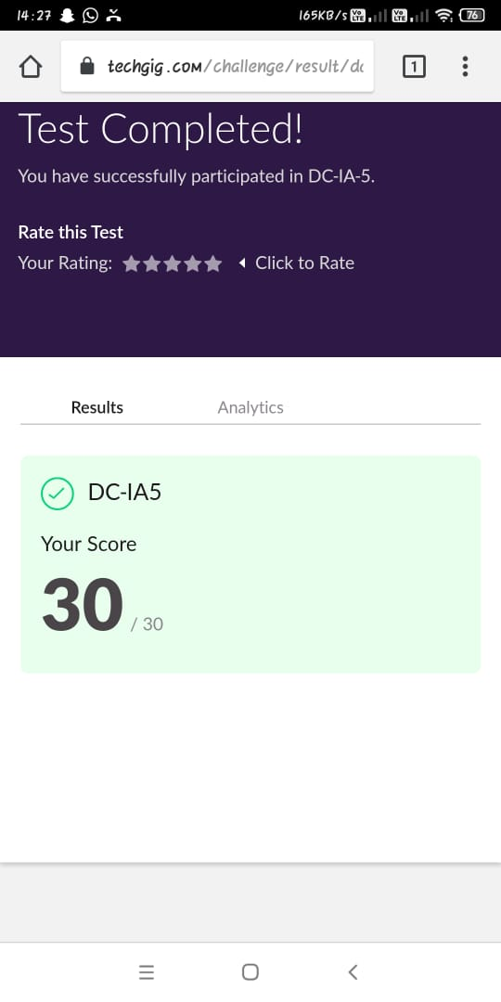

**Online Course Details:**

1. Name of course: **Microsoft Azure essentials**

Certificate provider: greatlearning

The total course was about how we can get thorough with what Microsoft azure is and how it’s beneficial in the branch of cloud computing. Today I went through the managed services of Azure where I went through Azure IoT, Azure Hub and related topics.

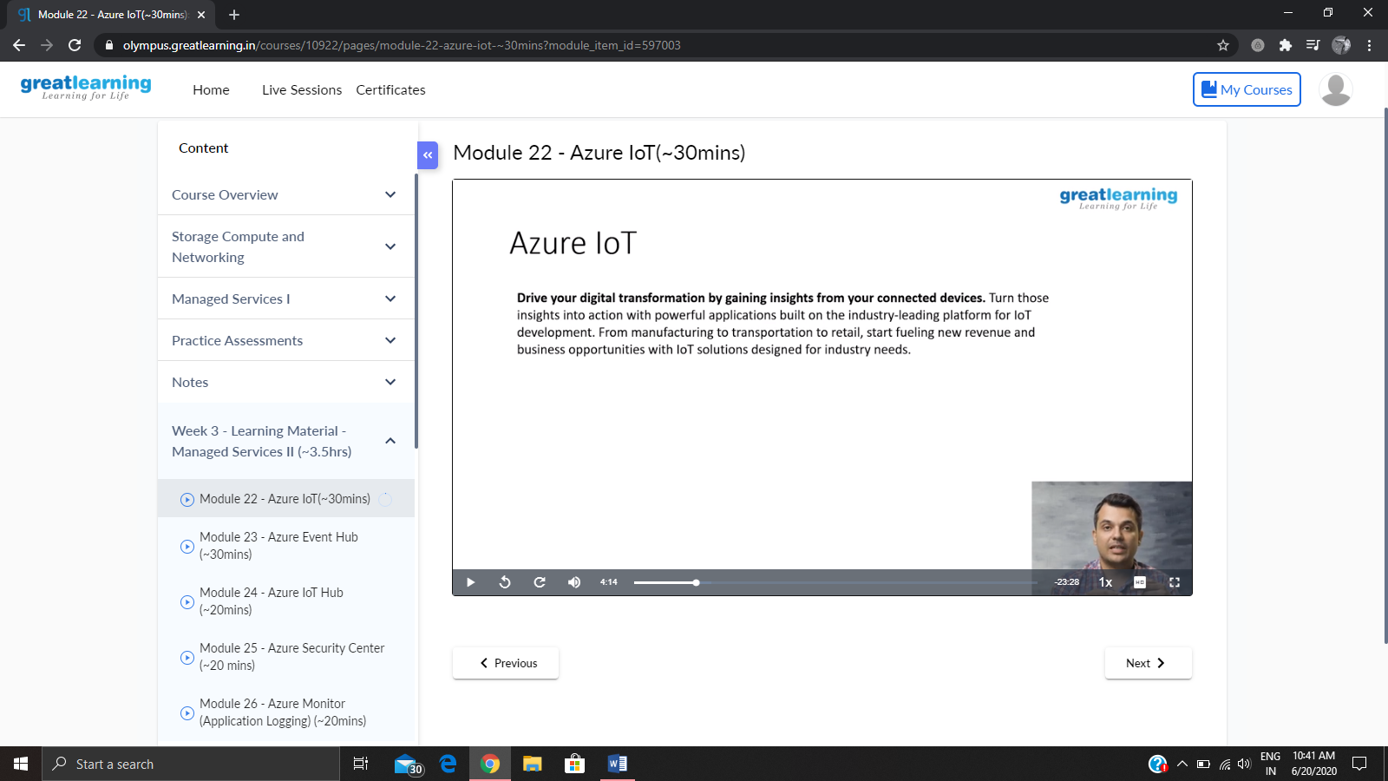

**Online coding:**

Problem 1: (using C language) Program to rotate a square matrix by 90 degree either clockwise or anti-clockwise

